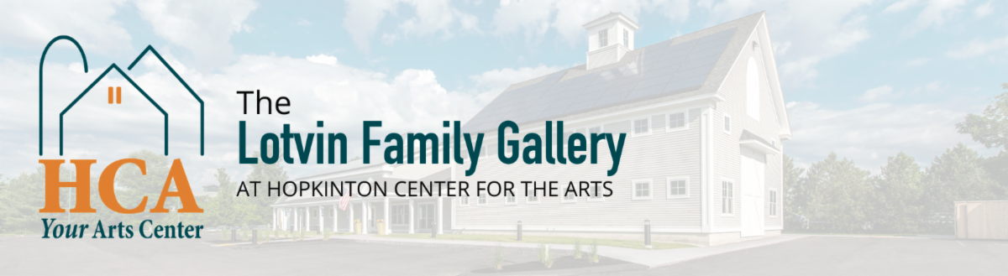

FOR IMMEDIATE RELEASE
PUZZLED
Artists Fernando Fula, Dani Tedesco, Jean Cummisky, Marjorie Ball and Eileen Riley.

Exhibition Dates: June 30 - August 27, 2026
Opening Reception: Friday July 24th, 6-7 pm
FOR PRESS-READY IMAGES CONTACT:
Sarah Alexander, Director of The Lotvin Family Gallery, sarah@hopartscenter.org, (508) 435-9222

The Hopkinton Center for the Arts (HCA) is pleased to announce that it will be hosting “Puzzled” in the Lotvin Family Gallery.
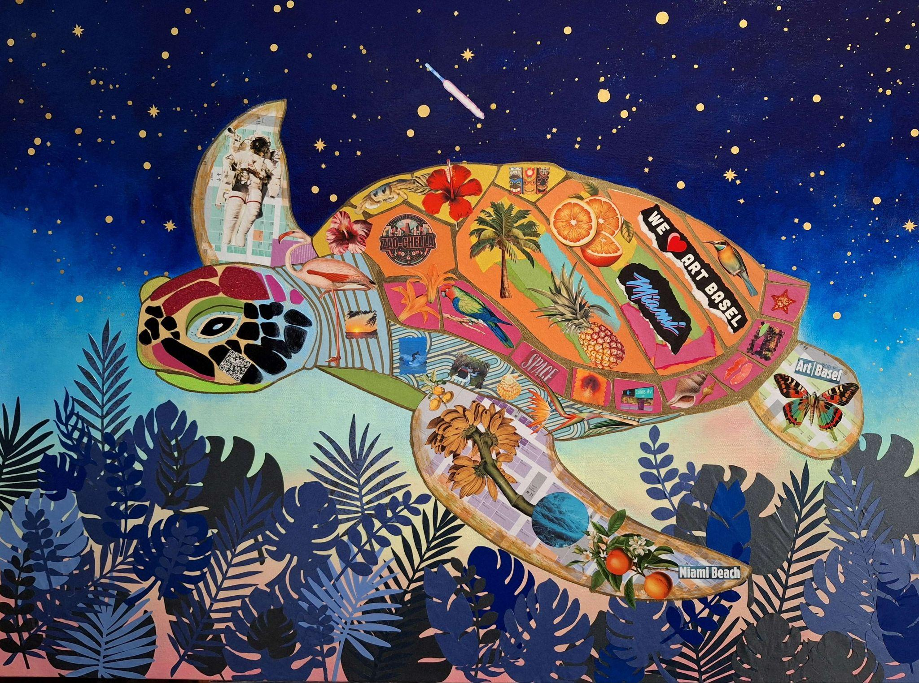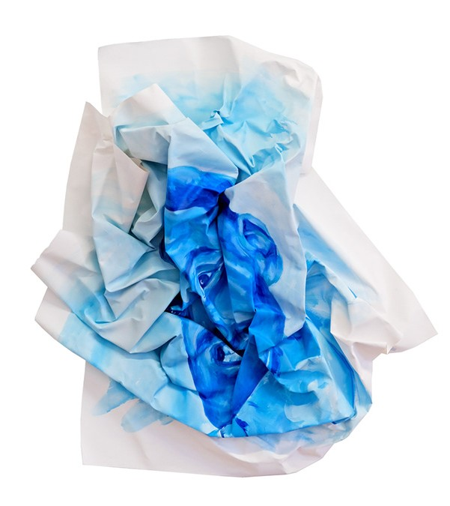
Artist Eileen Riley Artist Fernando Fula

About the show:
This exhibition invites viewers to explore the concept of puzzles, objects composed of interlocking pieces, shapes, and patterns that both intrigue and challenge the mind. Much like visual riddles or brain teasers, puzzles prompt us to look closer, reconsider what we see, and engage with the process of discovery.
Featured artists in this exhibit use patterns, shapes, and elements to create unified works of art. Their creative process involves combining individual elements—each with its own size, texture, and color—to construct something greater than the sum of its parts.
While a single shape may seem simple or insignificant on its own, its true potential emerges when it is joined with others. The dynamic interplay of diverse shapes, textures, and colors results in compositions that are both complex and striking, demonstrating how unity can transform ordinary pieces into something remarkable.

About the Artists:

Fernando Fula:
Born and raised in East Somerville, Massachusetts, Fula grew up in a home framed by movement and noise, train tracks on one side, highway on the other. He is a contemporary visual artist whose work explores identity, transformation, and spiritual rebirth. His art practice blurs the boundaries between abstraction and portraiture, using bold color, layered texture, and symbolic form to reflect the human experience of rebuilding the self. Fula’s artistic philosophy challenges the commodification of creativity. For him, art is not a product but a lived condition, a continual dialogue between faith, doubt, and renewal.

Dani Tedesco:
Dani Tedesco grew up in Caracas, Venezuela, surrounded by public art, kinetic color, and bold geometric forms woven into everyday life. She later lived in Brazil and Scandinavia, where she discovered that color and geometry could exist through both celebration and silence.
Now based in Massachusetts, Dani creates geometric paper sculptures and large-scale installations that reinterpret nature through precision, movement, and emotion. Her work transforms paper into immersive forms that feel simultaneously fragile and monumental — emotional talismans and quiet acts of resistance against entropy.
Working with paper for its accessibility, vulnerability, and unexpected strength, Dani explores how structure, repetition, and color can create moments of wonder, reflection, and connection within public and shared spaces.

Eileen Riley:
Eileen Riley’s artistic odyssey weaves a vibrant tapestry of creativity, rooted in the evocative landscapes of rural Massachusetts. The ocean’s restless tides, whispering woodlands, and sprawling farmlands of her youth ignited a lifelong passion for translating nature’s poetry into art. A sculptor by training, Eileen honed her craft at the University of Massachusetts, where she explored the tactile alchemy of form and material. Her journey since has been a dynamic evolution, marked by bold experimentation across mediums—pottery, painting, photography, collage, assemblage, and beyond.
As the Scholarship Chairperson on the Board of Directors for Westport Art Group, she champions emerging talent, ensuring the next generation of artists can flourish. While she occasionally shares her expertise through classes at Westport, her primary focus is her own artistry—crafting works that resonate on national stages and, soon, international ones, as she sets her sights on global exhibitions.

Jean Cummiskey:

Jean was born in Boston and raised in Quincy, Massachusetts on the edge of Quincy Bay. On clear days you could see Boston. Home today is Hopkinton, a mere 26 miles from Boston and the start of the Marathon. Taking photos of nature and copying cartoon characters were her earliest artistic endeavors. She pursued these areas in college with a double major in studio art and political science in pursuit of a potential career in political cartooning. While a graduate student in urban health and environmental planning, she continued her artistic development as an avocation through woodcuts, cartoons, and photography. She has come to appreciate the use of mosaics as aesthetic elements and community engagement tools. Her foray into mosaics reflects a personal and professional evolution, but the subject matter continues to include nature, the environment, and cities.
Marjorie Ball:
Marjorie Ball grew up on Long Island. Her early love of drawing and painting was encouraged and developed by classes at the Art Students League, Pratt Institute, and private painting lessons with a local professional illustrator. After graduating from Syracuse University school of art she worked as an illustrator, freelance graphic designer, and art educator in Massachusetts and Rhode Island. Throughout those years, she painted and exhibited her work in local exhibitions, waiting for a chance to follow her heart and paint every day.
Marjorie now paints in her studio in Ashaway, RI. Her paintings have appeared in many juried exhibits and have won multiple awards.

Entry to view the exhibition is always free. The HCA is pleased to offer private and group docent tours upon request. For more details, call 508-435-9222 or visit our website at www.hopartscenter.org

About Hopkinton Center for the Art:
- Vision: The region’s cultural destination–where passions emerge and the creative spirit thrives.
- Mission: Serving individuals of all ages, cultures, and artistic abilities across the MetroWest region, the HCA develops artistic skills, offers outstanding performances and art exhibitions, and enables visitors to experience art in all forms. Under one roof, we celebrate art through classes and events in visual art, theater, music, dance, ceramics, writing, and film.

About the Lotvin Family Gallery: Learn about art and learn through art—at any age. Look, imagine, discuss, write, and make. The Lotvin Family Gallery is a space where contemporary art and learning meet. We believe that artists are educators, cultural workers, researchers, public intellectuals, and activists who help us see ourselves and the world in new ways.

CONTACT:
Sarah Alexander, Director of The Lotvin Family Gallery
sarah@hopartscenter.org
508-435-9222
Hopkinton Center for the Arts
98 Hayden Rowe St
Hopkinton, 01748
https://www.hopartscenter.org/home

